A DETAILED ARTICLE ON PUSHING A DIRECTORY TO GITHUB REPOSITORY

Note: We are using Git Bash for this

1. Locate the directory you want to push to GitHub and open it using git bash

How to Open a directory using Git Bash:

* I want to push the content of the directory “***file_to_push”*** to GitHub
* Open the directory you wish to push to GitHub
* Left click in the background of the file and select ***Open Git Bash here***

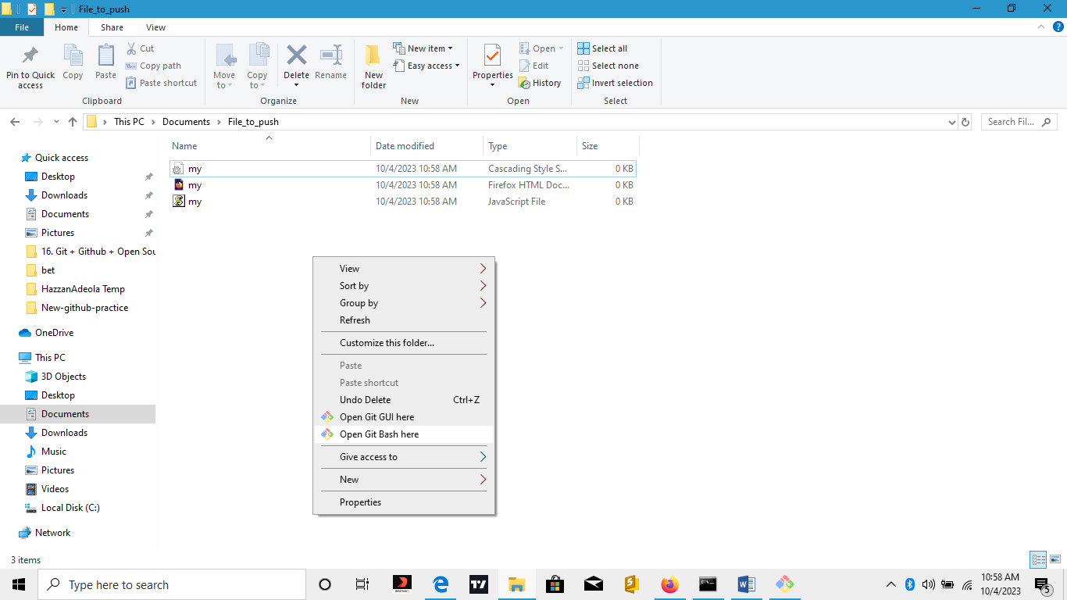

This the environment of Git Bash

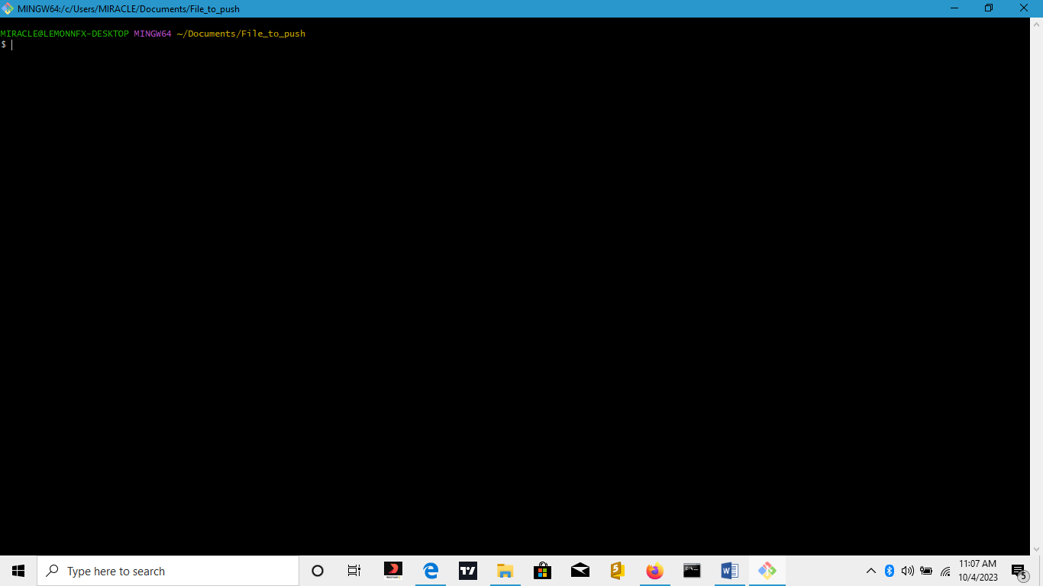

1. List the content of the file using the command ls

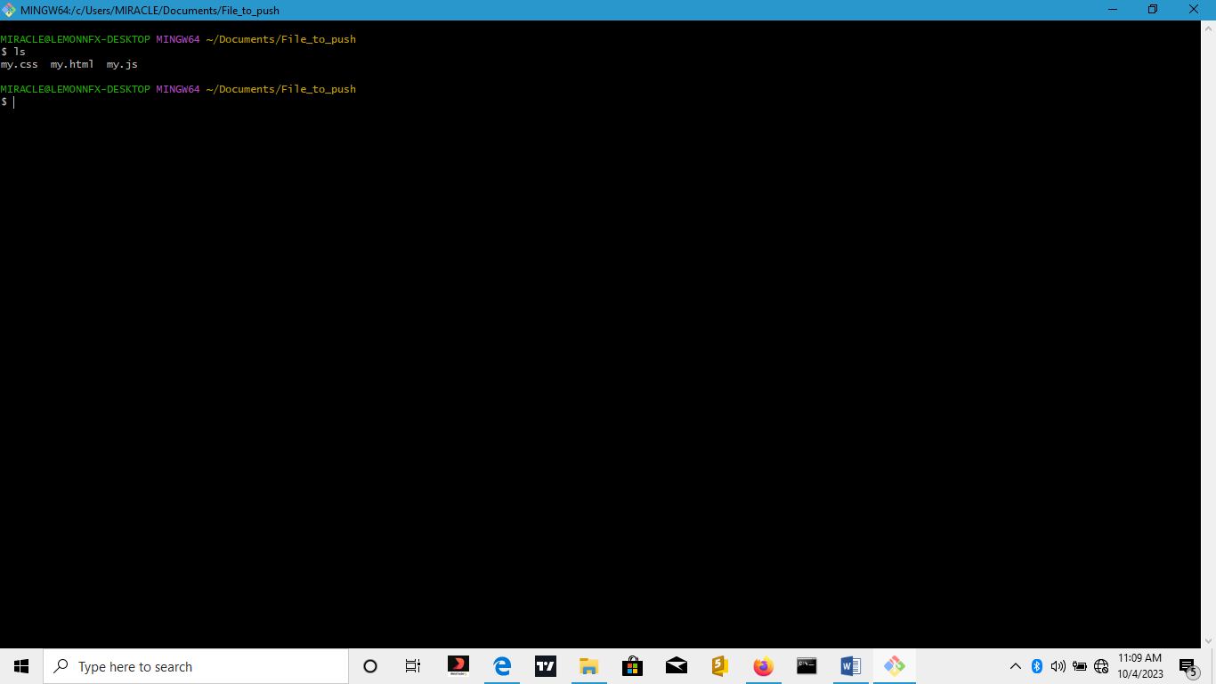

1. Set up your GitHub email and username using the command

$ git config –global user.email “your email”

$ git config –global user.name “your username”

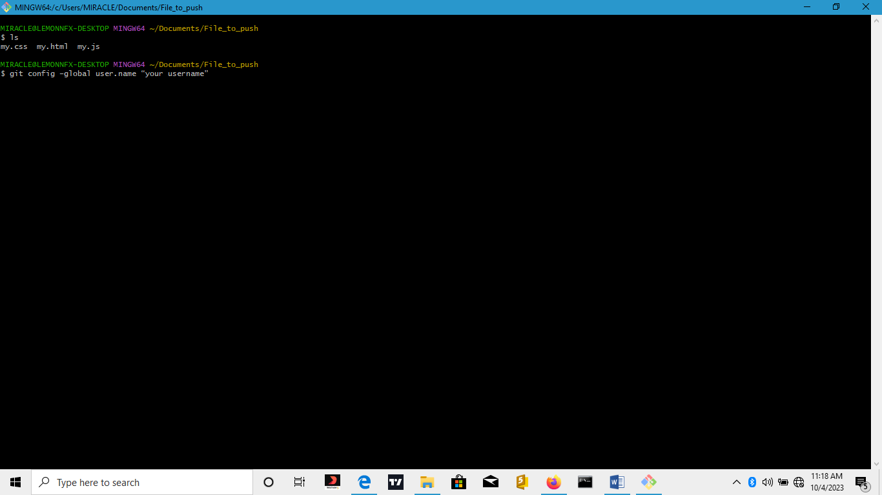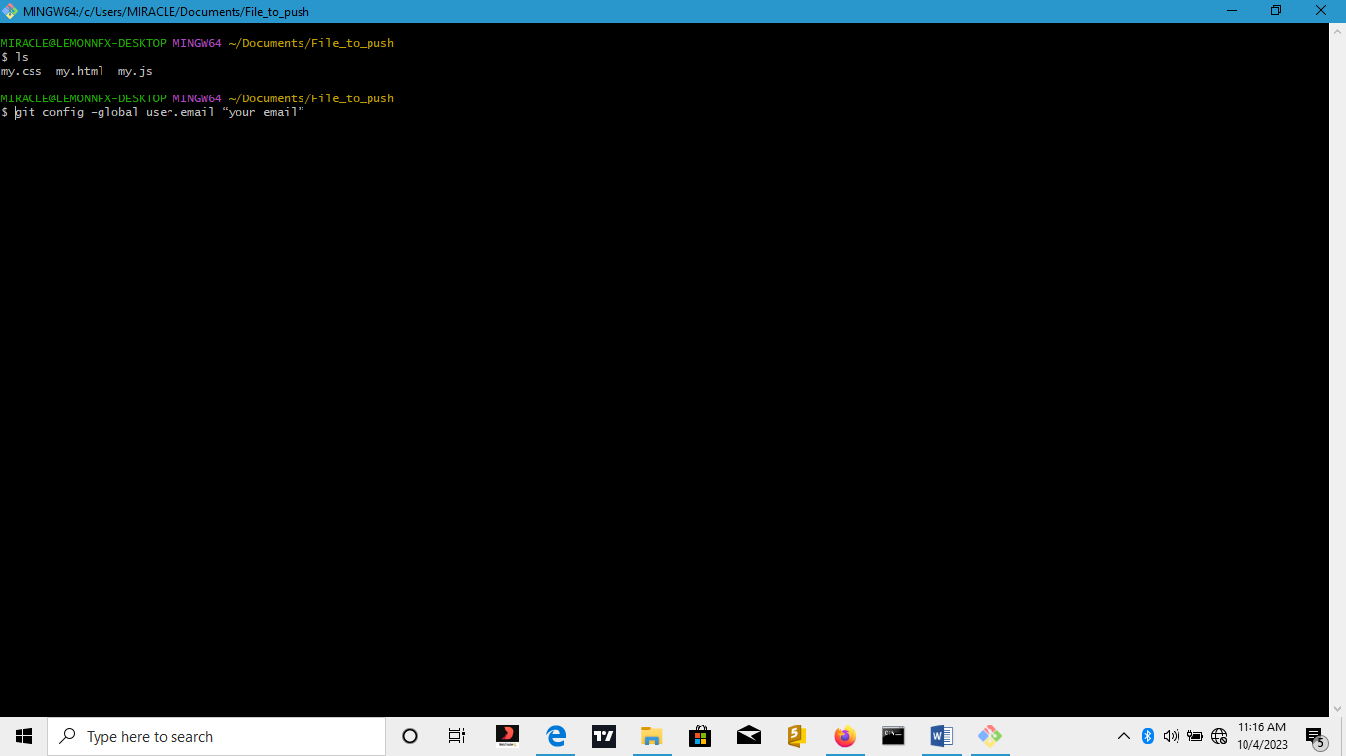

1. Use the command git initto create a new Git repository **.git**

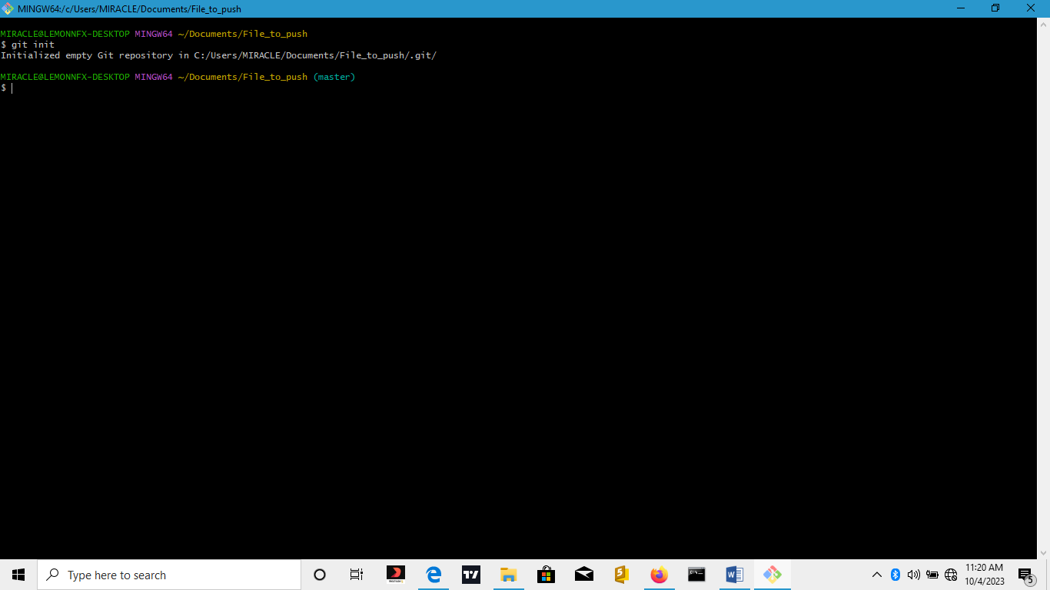

1. Type the command git status to display the current status of the local repository

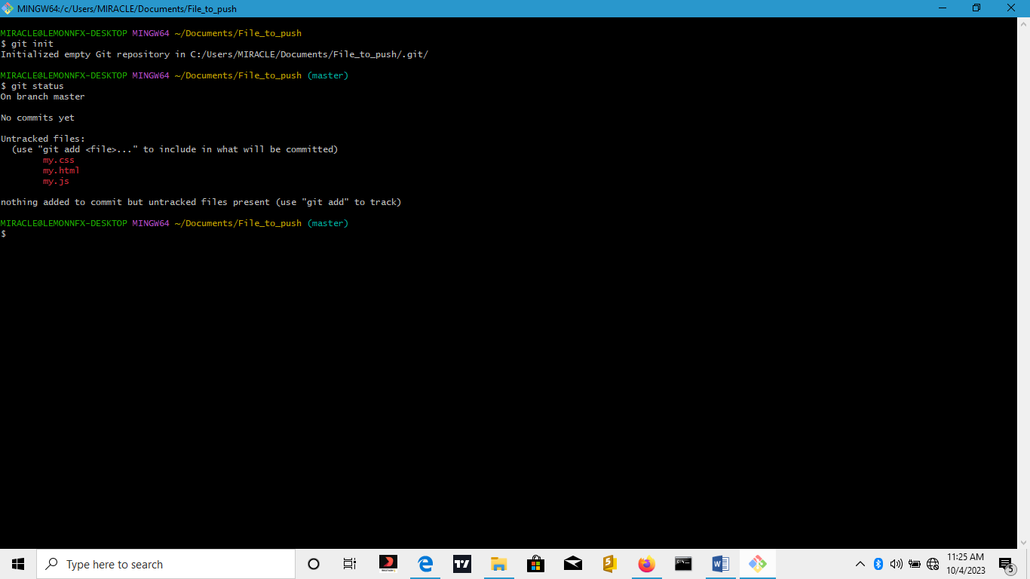

1. Type the command git add ***.*** to add all the files to be committed

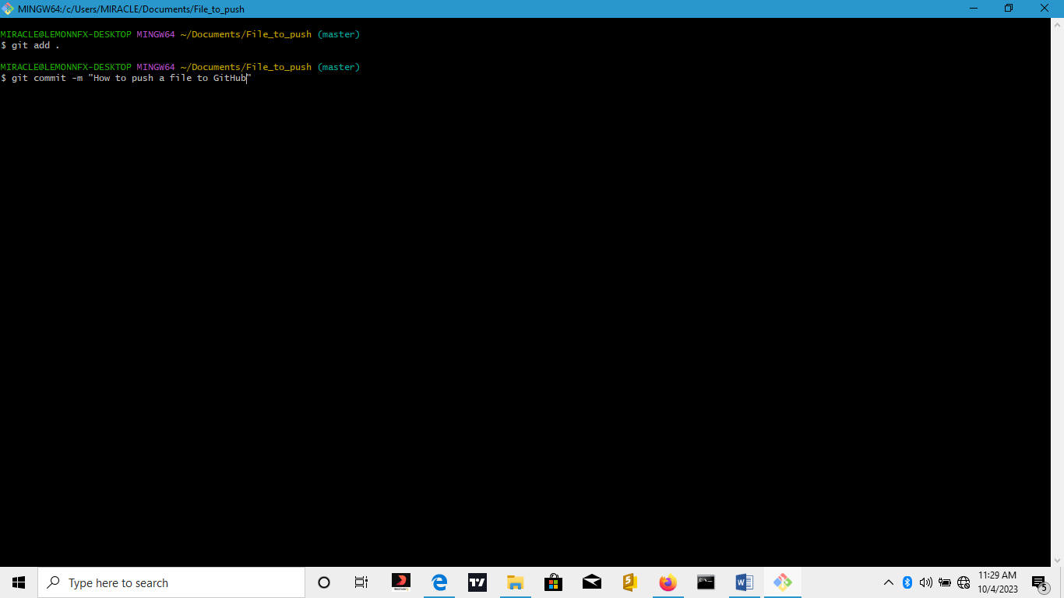

1. Type the command git commit –m “How to push a file to GitHub”



1. Go to your GitHub account and create a repository with the same name with the directory you want to Push and copy Git URL

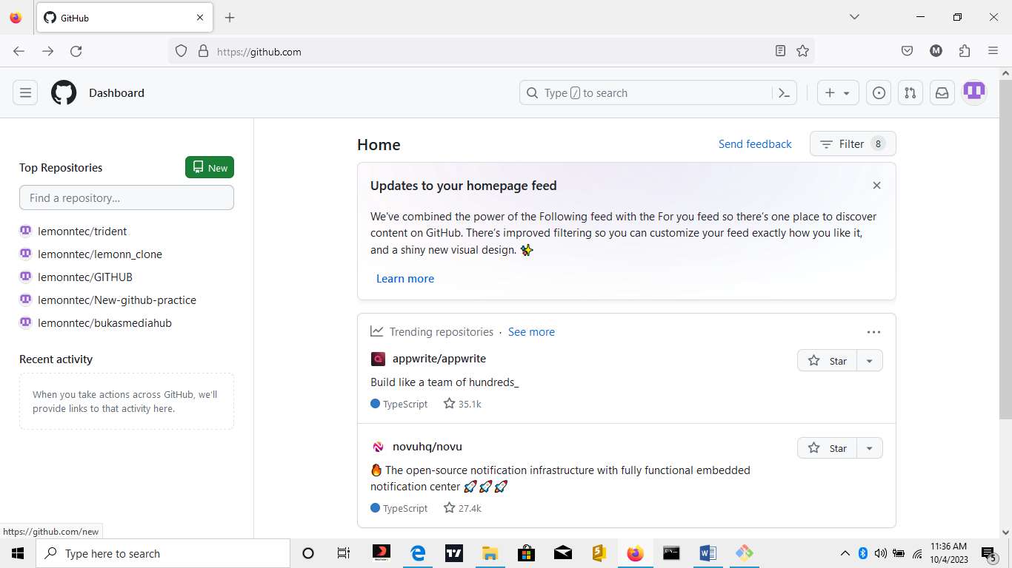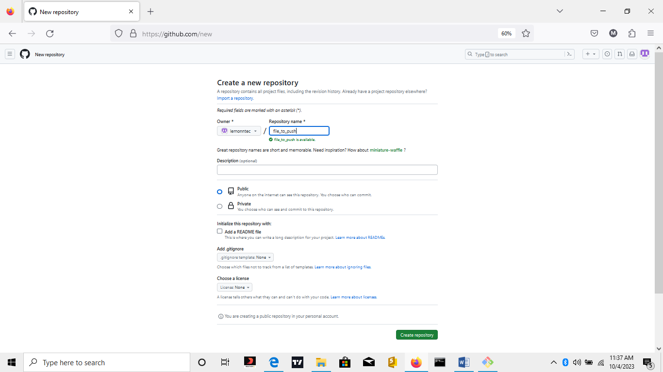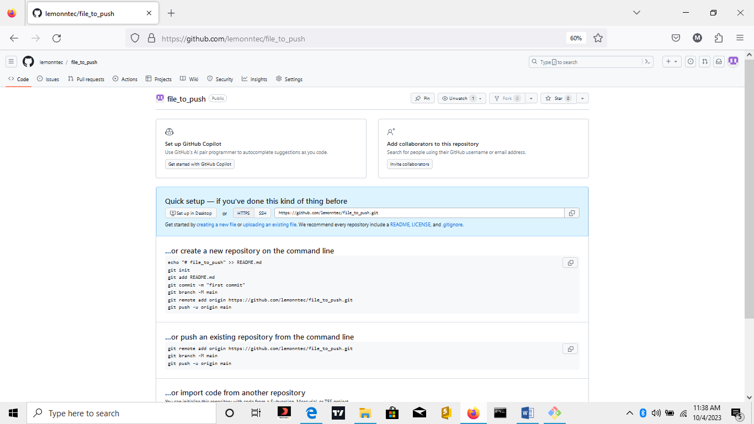

**1**

**4**

**3**

**2**

1. Add the remote repository by typing the command git remote add origin https://github.com/lemonntec/file_to_push.git

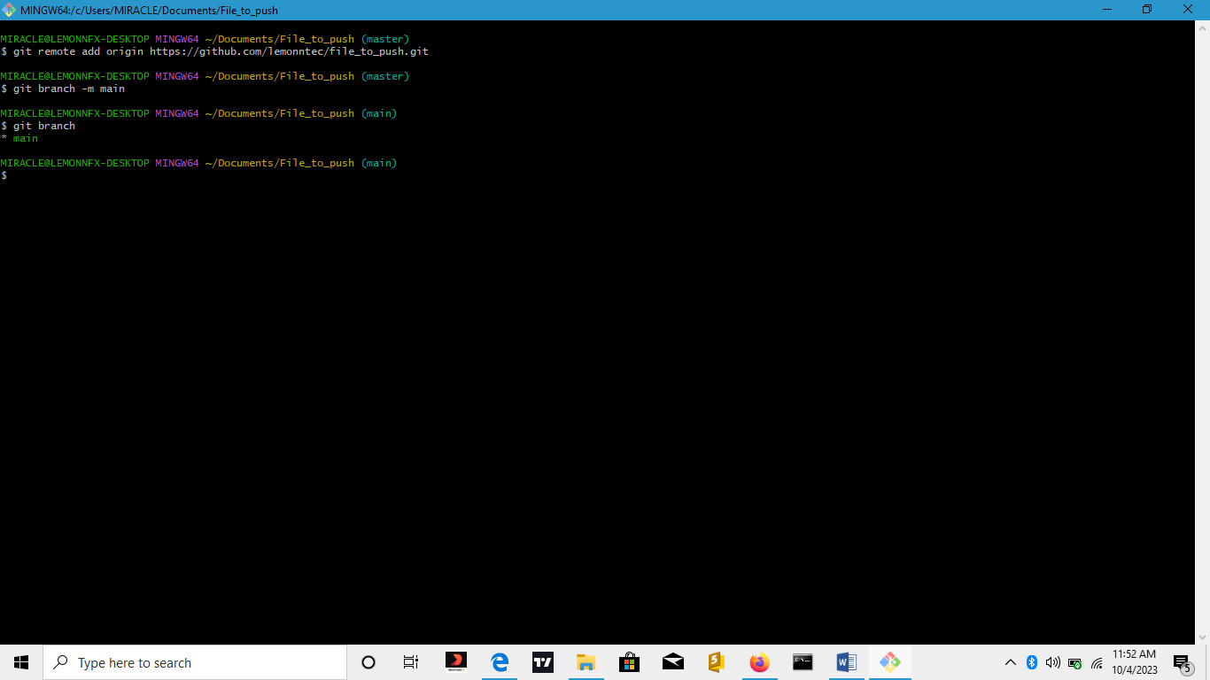

1. Type the command git branch -m main

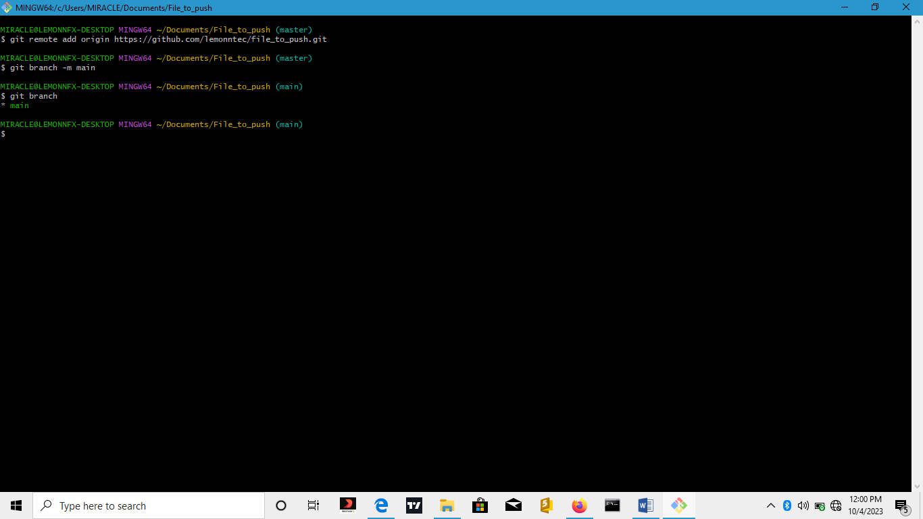

1. Then use the command git push -u origin main

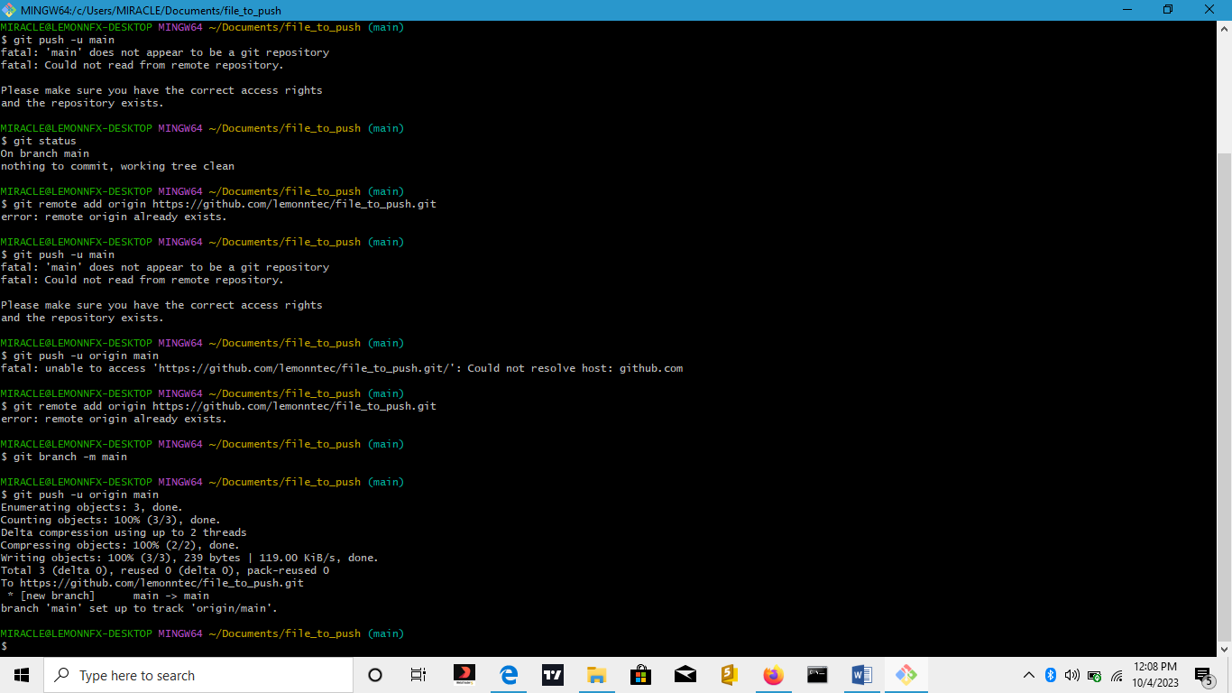

1. Then, go to your GitHub account to see the files

